https://services.arcgisonline.com/arcgis/rest/services/Demographics/USA_Median_Age/MapServer/4/query?text=Vermont&returnGeometry=false

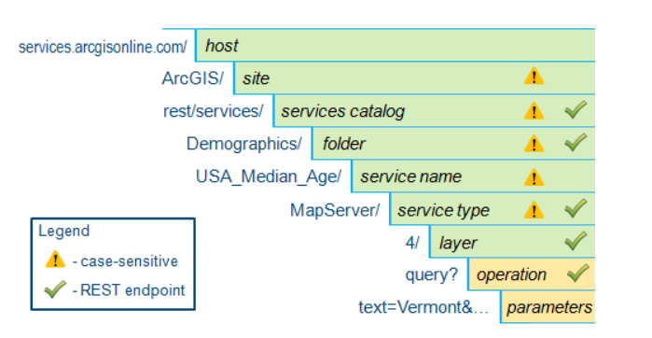

# Methods for sending requests

As indicated by these buttons, the REST API supports two HTTP methods for sending requests: GET and POST.

Using GET allows you to bookmark specific resources and operations (with specific parameters) in your browser. For example, you can bookmark a particular map query that you want to perform regularly.

But there are two common situations in which the GET method will not meet your needs:

* Long requests—The length of a URL is limited to as few as 1,024 characters by some browsers. Request URLs often exceed that length when they include geometry information (coordinates), spatial reference text descriptions, or even sufficiently complex attribute query criteria.
* Altering the server—In some situations, you may want to modify the data stored on the server. For example, you may want to add a new feature to an editable data layer. For safety reasons, requests that effect a change to the state of the server cannot be sent using GET (for example, think about the dangers of bookmarking a request to delete all features).

Ｐｏｓｔ

* The length of the POST body can safely exceed 1,024 characters. Requests sent by POST cannot be bookmarked because bookmarks record only the URL, not the body, of the request.

# Formatting the responses

